Experiment-9

Views

1. Create a table student attributes stdno, name, dept

2. Display

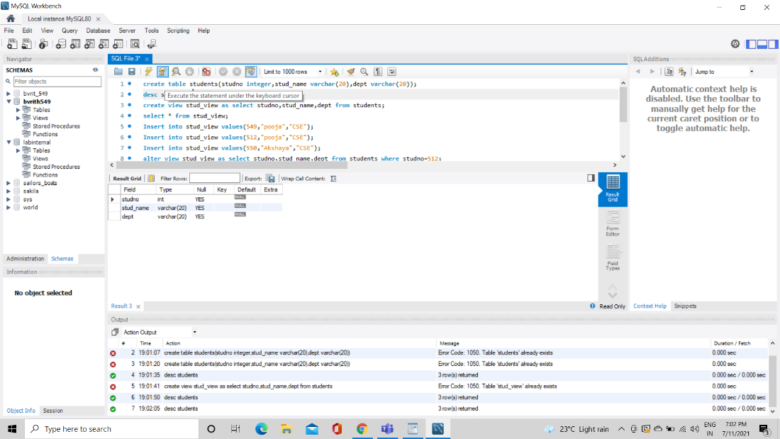

3. Create view and select

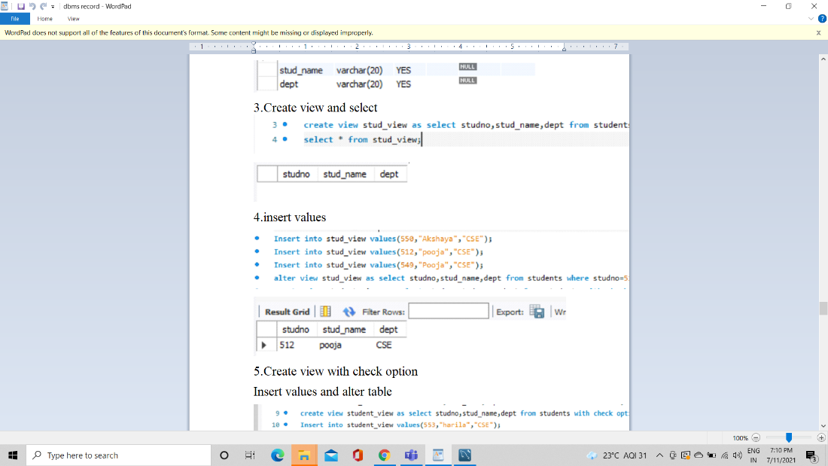

4. Insert values

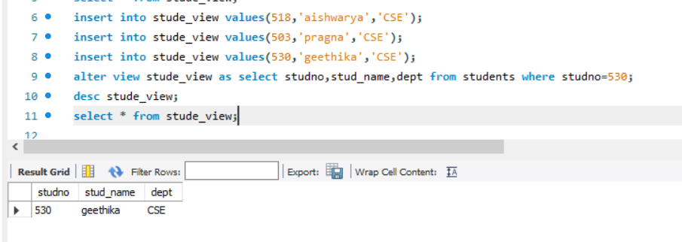

5. Create view with check option

Insert values and alter tables

